What does scaling a database horizontally or vertically mean?
Scaling a database can be done in two main ways: horizontally or vertically, each with its own approach to handling increased demand or traffic. Here's what they mean:

1. Vertical Scaling (Scaling Up):
- Definition: This involves increasing the capacity of a single server (or node) by adding more resources, such as CPU, RAM, or storage.
- How it works: You upgrade the server hardware to handle more data or user requests. The database continues to run on the same machine, but that machine becomes more powerful.
- Advantages:
  - Simpler to implement, especially for traditional databases.
  - Less complexity in managing multiple servers.
- Disadvantages:
  - There is a physical limit to how much you can scale up one server.
  - Downtime may be required during upgrades.
  - Can become expensive as more powerful hardware is needed.

2. Horizontal Scaling (Scaling Out):
- Definition: This involves adding more servers (or nodes) to your database system to distribute the load across multiple machines.
- How it works: The database is split across different servers, and each one handles part of the data or traffic. In some setups, the database is replicated across servers to provide redundancy.
- Advantages:
  - No upper limit to how much you can scale, as you can keep adding more servers.
  - High availability and redundancy, as the failure of one server won't take down the entire system.
  - More suited for distributed databases or NoSQL databases like Cassandra, MongoDB.
- Disadvantages:
  - More complex to manage, as you need to handle distributed data and synchronization.
  - May require changes to the application logic to work with distributed data.

Summary:
- Vertical scaling: Upgrade the server to a more powerful one.
- Horizontal scaling: Add more servers to handle the load.
Each method has its use cases depending on the type of database, the volume of data, and the required availability.

Which of the following statements represent the key disadvantages of NoSQL?
- They do not rely on tabular, highly structured data models.
- Full ACID transaction support is often sacrificed.
- Limited support for joins and other aggregations across multiple datasets is available.
- It comes with a steep learning curve because different data models and query languages are required for specific data model designs.
Only b, c, and d

Which of the following is not a type of NoSQL database management system?
A: MongoDB
B: MySQL
C: Redis
D: Apache Cassandra

Which of the following is a key advantageous characteristic of NoSQL databases?
A: They excel when data consistency is required.
B: They do not rely on tabular, highly structured data models.
C: They are useful when complex joins and aggregations across multiple datasets are required.
D: They are vertically scalable.

True or false? NoSQL databases can only handle unstructured data, not structured data.
A: False
B: True

In terms of development time, how does NoSQL compare to relational databases?
A: NoSQL and relational databases have similar development times.
B: NoSQL requires more development time.
C: Development time is not affected by the choice of database.
D: NoSQL allows for much faster development.

True or false? NoSQL databases prioritise consistency over availability to ensure data integrity.
A: False
B: True

Which type of NoSQL database is known for storing data in easily parsable document formats like JSON and BSON?
A: Column-oriented databases
B: Key-value stores
C: Graph databases
D: Document databases
Which of these statements describes a limitation of relational databases when it comes to big data scenarios?

A: They cannot ensure that database entries are valid and protected against insertion errors.
B: They lack support for Structured Query Language (SQL).
C: They struggle to perform well in large-scale data environments.
D: They cannot ensure data compliance.

SQL vs. NoSQL Database Systems
https://youtu.be/KGBEXgqGP9c?si=Qp9prM49ON1zb2dK
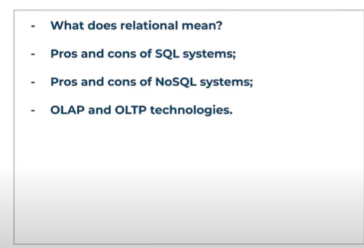

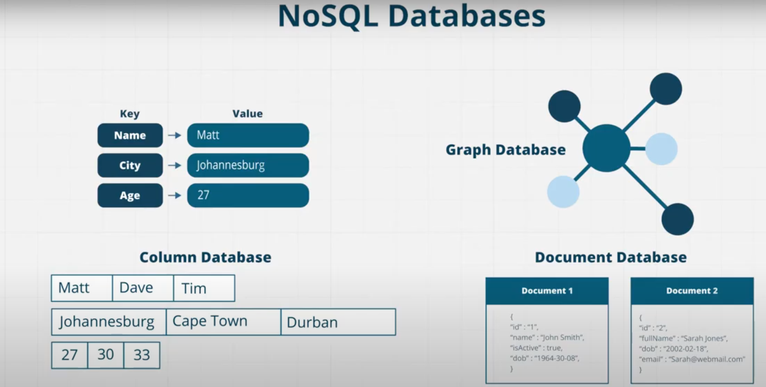
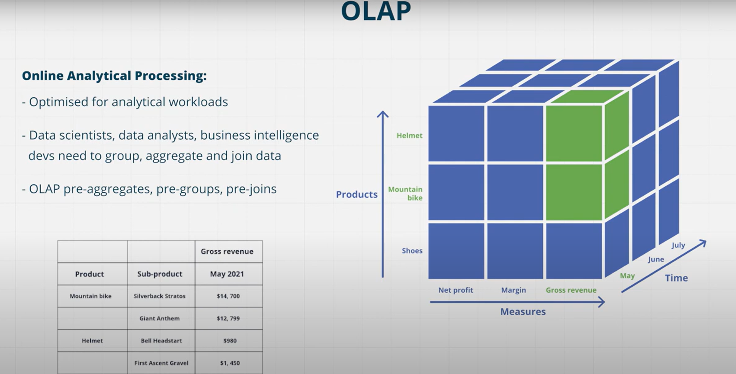

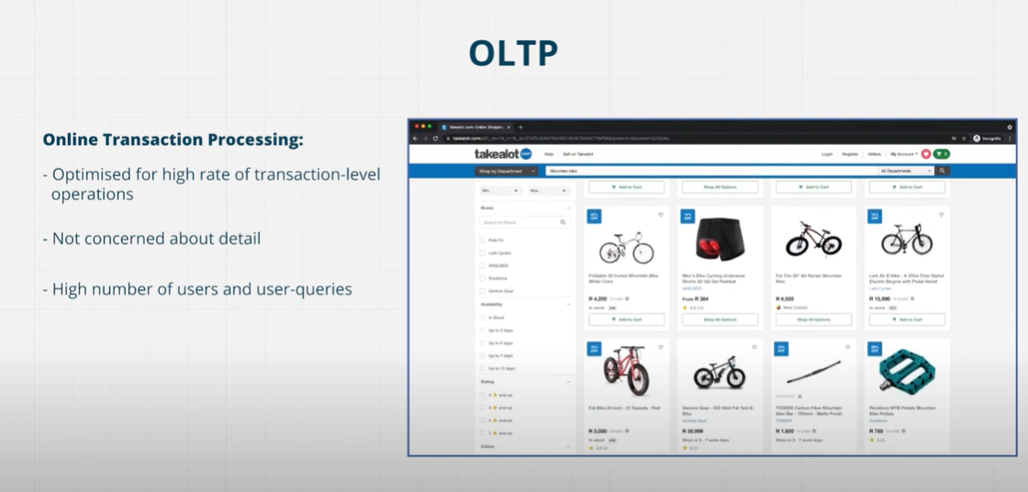

OLTP transactions include booking tickets for flights, concerts, texting, purchasing groceries online, searching an e-commerce website, etc.
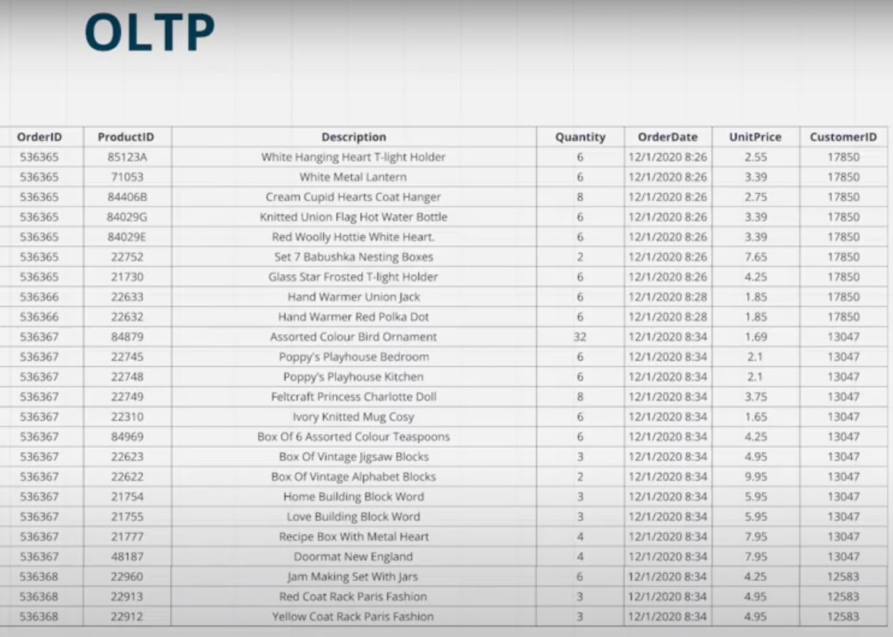
Because we’re concerned with data at transaction level, we’re not worried about aggregating and joining.
Common operations are;
- INSERT
- UPDATE
- DELETE
In contrast to OLAP which summarises data for reporting, OLTP is used for day to day operations of a business.

Test Your knowledge
Which type of database is primarily used for data analysis?
A: NoSQL
B: OLAP
C: NewSQL
D: OLTP

Which operation in OLAP allows you to view data in increased detail?
A: Roll-up
B: Drill-down
C: Slice and dice
D: Pivot

True or false? OLTP databases are designed for a smaller number of users compared to OLAP databases.
A: True
B: False
What does OLAP stand for?
A: Online Analytical Processing
B: Online Transactional Processing
C: Online Linear Analytical Processing
D: Online Logical Analysis and Processing

